
3D Visualisation of Satellite Imagery
OO Diagrams
Team Imagery
Damian Brockie
Rowan James
Shane Kingston
Matthew McKellar-Spence
Dafydd Williams

Package Diagram
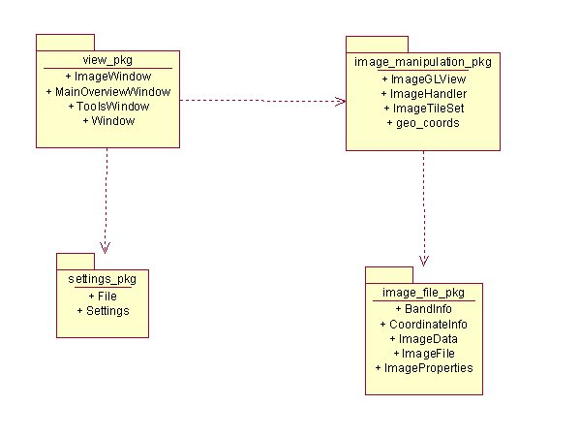

Class Diagrams

Image_File_PKG
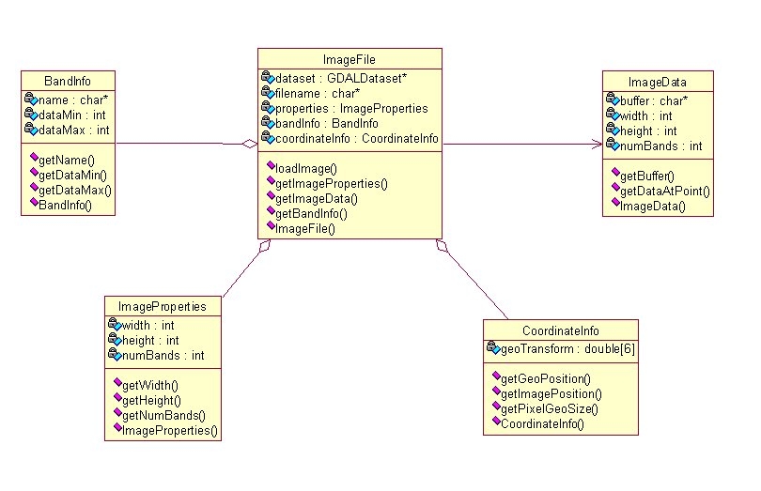

Image_Manipulation_PKG
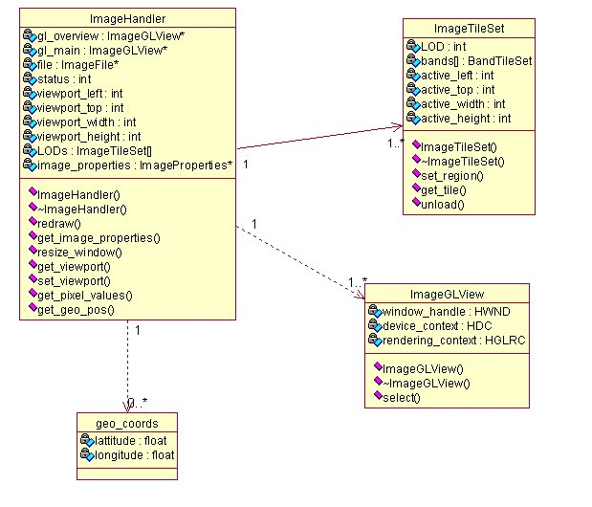

View_PKG
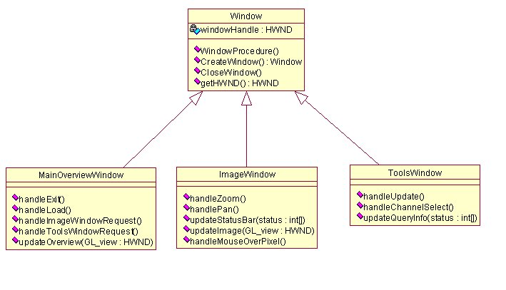

Settings_PKG
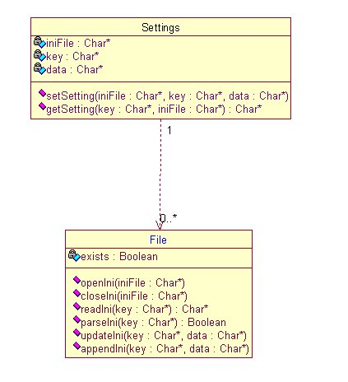

Sequence Diagrams

Use Case 4: User Arranges Windows
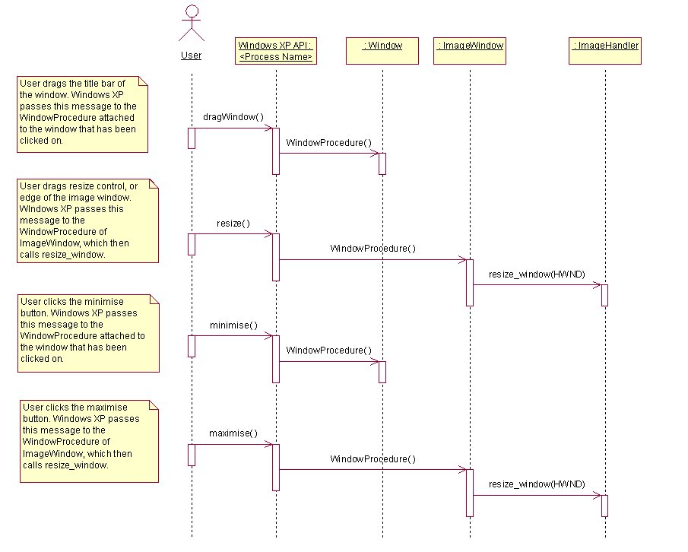

Use Case 7: User Loads Image
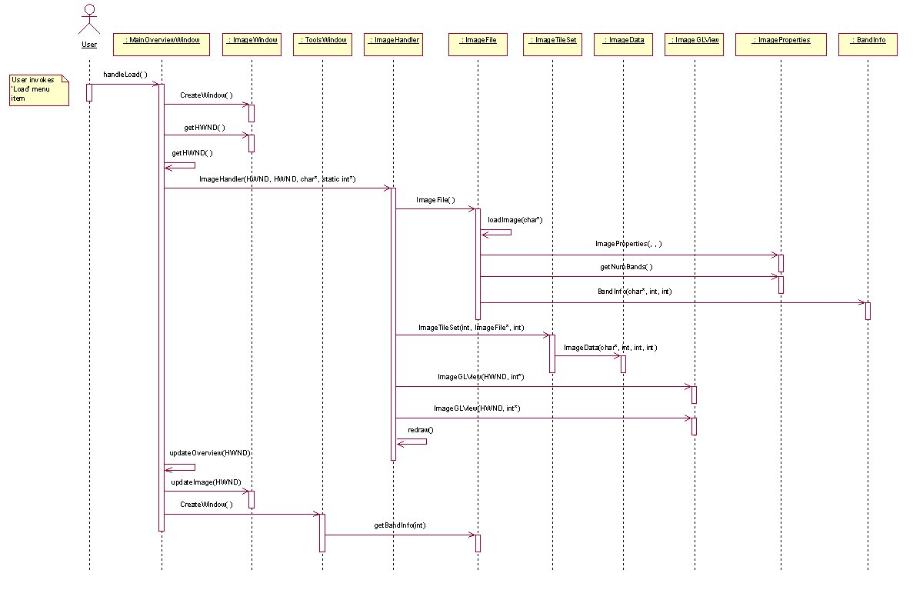

Use Case 9: User Queries Pixel
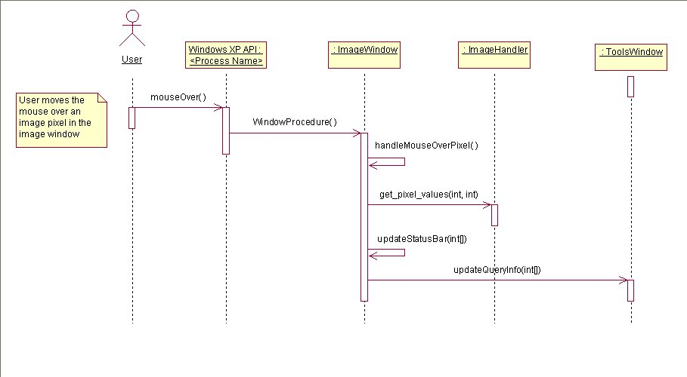

Use Case 10: User Selects Display Channels
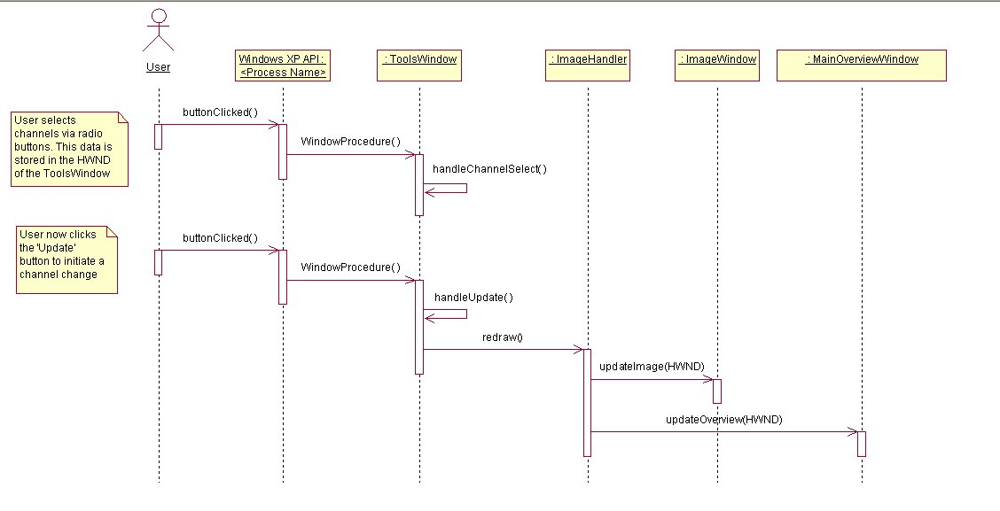

Use Case 13: User Pans Image
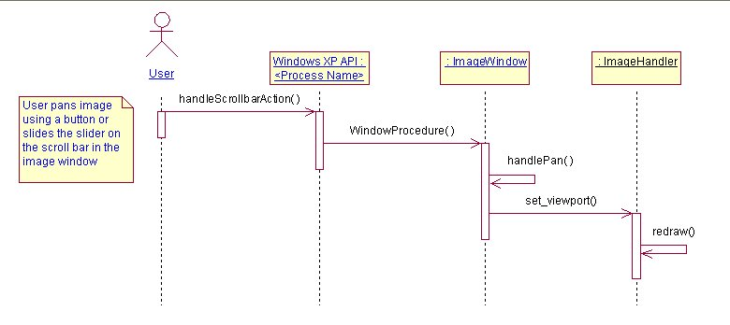

Use Case 14: User Zooms Image
